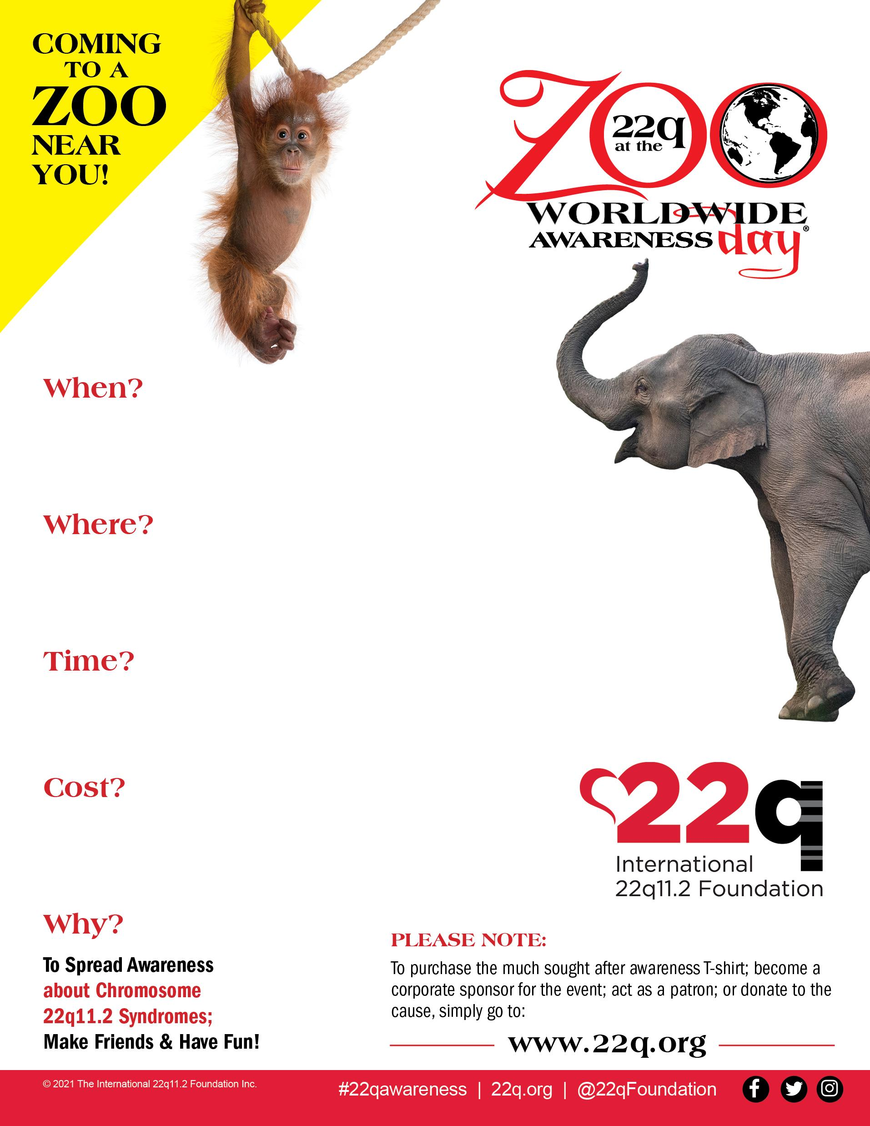

**May 22nd, 2022!**

Four Free tickets per family

Additional tickets $10 plus lunch

10 A.M. - 2 P.M.

**The Turtle Back Zoo**

560 Northfield Ave.

West Orange, NJ 07052