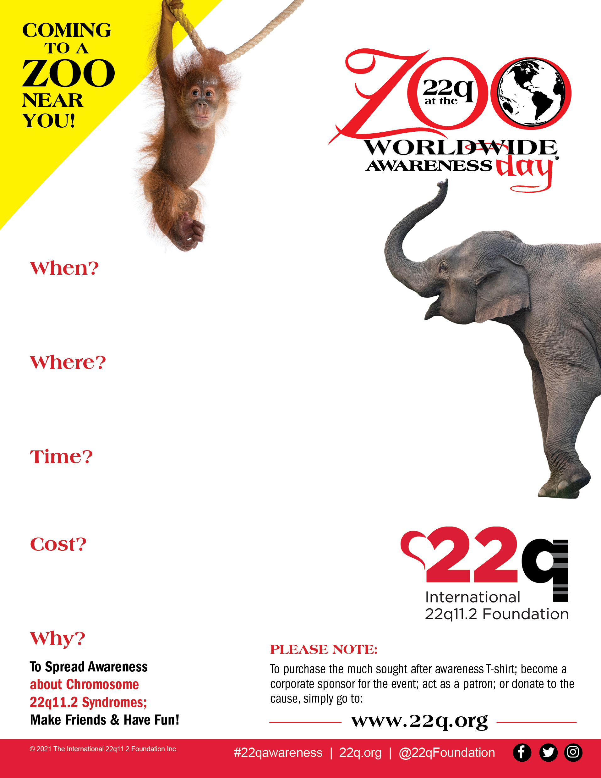

$11.75 per person ages 2+

FREE for children under 2 years old

**9:30am-2:00pm**

Lunch will be provided!

**Saturday, May 21st 2022**

dfdf

**Richmond Metro Zoo**

8300 Beaver Bridge Rd

Moseley, VA 23120