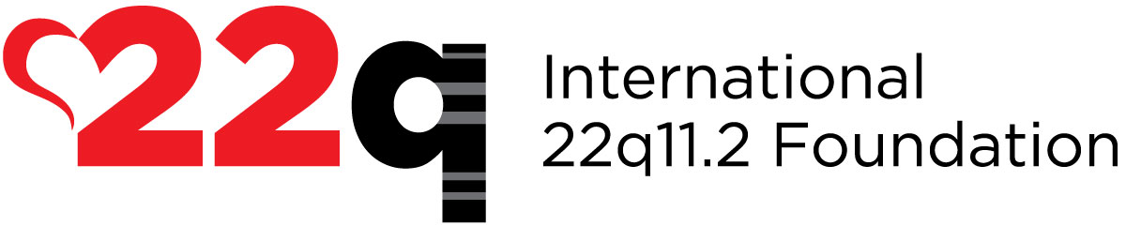
Dear Friend,

I am writing to ask for your help. Let’s build an army of physicians, educators and researchers with the knowledge and tools to take on the challenges associated with 22q11.2 differences. Can you imagine what life could hold for those children and their families if they could depend on early diagnosis and timely interventions and treatment?

Better still… what if someday emerging scientific research could help CURE certain symptoms?

YOU can help make this happen! Please join me in helping the International 22q11.2 Foundation raise awareness around the world and support research on 22q11.2 deletion and duplication syndromes. While we have made enormous progress since our inception in 2003, with your help, we can do more!
Your support can help us as we:

- Expand our Family Support Network to include all 50 U.S. states and international partners;
- Enhance our “Talk About 22q Campaign”, leading to awareness, greater detection and improved care;
- Fund research by young scientists, which can both increase knowledge about 22q and engage young professionals who may go on to focus on 22q during their career; and
- Make Newborn Screening for 22q a reality so no family misses a window of treatment opportunity!

Your support will help meet the needs of countless parents and medical professionals who reach out to the International 22q11.2 Foundation for guidance.

I am part of the campaign to Tell 22 Friends About 22q – and I’m counting on you to be a partner in this important work! I’ve attached the Fact Sheets on 22q to this letter so you can learn more about both 22q Deletion and 22q Duplication Syndromes.

Please help make a difference for the thousands of families who are facing the isolation, confusion, and heartache of coping with 22q11.2 in a world that is completely unaware.

Thank you for your participation. We cannot begin to express what it means to the families that we support. Please visit www.22q.org to learn more about our important work. Please also consider giving a gift to support our mission using the form below or via our website.

Thank you for being part of Team 22q!

(Your Name Here)

THANK YOU! You are about to become a part of our largest global public awareness campaign ever!

When you donate to the International 22q11.2 Foundation you become a vital link in the 22q chain of support for individuals with 22q deletion and 22q duplication.

---------------------------------------------------------------------------------------------------------------------------------------
Tell 22 Friends About 22q!

YES, I want to help raise awareness about the vital work done by the 22q Foundation.

Please make checks payable to The International 22q11.2 Foundation, Inc.

___ Enclosed is a one-time donation of:

___$22 ___$50 ___$100 ___ $250 (other) $_______

Please charge my credit card for a one-time donation of:

___$22 ___$50 ___$100 ___ $250 (other) $_______

To donate online, go to www.22q.org. We accept MasterCard/VISA/American Express through PayPal.
Credit Card Number:

_____________________________________________________________________________________

Expiration Date: __________________________________ Code: ________________________________
Name: _______________________________________________________________________________

Address: _____________________________________________________________________________

Home Phone: _________________________________________________________________________

Cell Phone: ___________________________________________________________________________

Email: _______________________________________________________________________________

You can also mail a check (payable to The International 22q11.2 Foundation, Inc.) to:

The International 22q11.2 Foundation, Inc.
PO Box 532
Matawan NJ, 07747
USA
To support by phone, please call: +1 877-739-1849

