22q11.2 Duplication Syndrome:
FACT SHEET

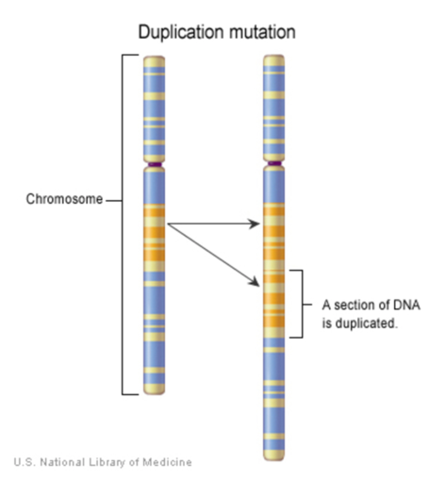

- Individuals with 22q11.2 Duplication Syndrome are born with an extra set of genes on chromosome 22. In most cases, the extra genetic material contains about 40 genes.

- 22q duplications are not detectable by karyotyping (an older method of genetic testing). Most individuals with 22q11.2 duplication are identified either by array genomic hybridization (array GH) testing or multiplex ligation-dependent probe amplification (MLPA) testing. Both tests are performed on blood samples. 22q duplications can also be diagnosed in pregnancy using cells from the placenta or the amniotic fluid.

- Many individuals with 22q11.2 Duplication remain undiagnosed, making it difficult to estimate the true prevalence of this syndrome. Best estimates fall in the range of 1/700 live births. Newborn screening will help identify the actual number of people who have the 22q11.2 duplication.

- Researchers are still in trying to find out more about 22q11.2 Duplication Syndrome and how it affects individuals.

- About 70% of individuals with the 22q11.2 duplication inherited it from a parent. When the duplication is not inherited, it occurs as a random event. Nothing that the parents did or did not do caused it to occur. Any person with the duplication has a 50% chance of passing it on to his/her child in every pregnancy.

- There is a wide variability in the types and severity of associated symptoms, including birth defects, medical problems, and developmental differences. 22q11.2 duplication can also result in very mild symptoms or none at all.

- Many children with 22q duplication have developmental delay or behavioral differences.

- Around 14 to 25% of individuals with 22q11.2 Duplication Syndrome have autism spectrum disorder.

- 22q duplication has been associated with differences in the heart, hormones, hearing, blood counts, ability to fight infection, brain and nervous system, eyes, head and neck, kidneys, and skeletal system.

- A diagnosis of 22q11.2 Duplication Syndrome generally leads to several screening exams including an evaluation by a cardiologist and an echocardiogram to examine the heart by taking ultrasound pictures.

- Individuals with 22q11.2 Duplication Syndrome may have problems in vision. Therefore, a complete ophthalmological examination as well as regular vision checks by a primary healthcare provider are recommended.

- 22q duplication can cause differences in the thyroid and calcium levels. Early diagnosis leads to early treatment and improved outcome.

- A hearing test can help identify possible hearing problems early on and provide remedies to minimize difficulties in school, work, and daily living.

- Medical evaluations may detect additional problems, but many therapies and interventions are available to manage them. It is always best to discover symptoms early to improve management. Individuals generally benefit from care at a 22q multidisciplinary center.

This information is brought to you by the Foundation for educational purposes only.
It is not intended to be taken as medical advice.
If you have concerns, please talk to your healthcare provider.

