22q11.2 Deletion Syndrome:
FACT SHEET

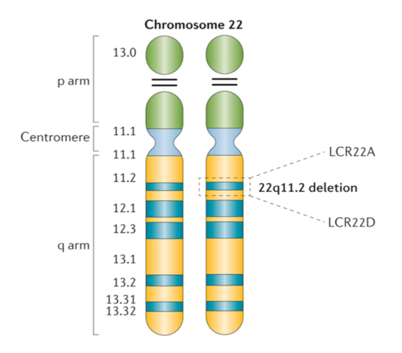

- 22q11.2 deletion syndrome (22q) is a genetic disorder caused by a missing piece of the 22nd chromosome.

- An estimated 1 in 2000 to 4000 children are born each year with 22q -- but this is likely an underestimation of the actual numbers.
- Medical and public understanding of this disorder is growing, but 22q is often misdiagnosed, under-diagnosed, or not diagnosed until years after birth.
- Genetic testing to confirm the 22q deletion is usually done using a simple blood sample sent to a clinical lab. The test involves sophisticated methods that can also reveal the size of the deletion.
- A 22q deletion is usually a new (instead of an inherited) genetic change that is not found in either parent of the patient, and the parents did not do anything to make it happen.
- Parents without the deletion are not at increased risk of having a second affected child. However, a person with 22q deletion has a 50% chance of passing it on to his or her child with every pregnancy.
- The genetic deletion can affect every system in the human body with nearly 200 mild to serious health and developmental issues.
- Newborn diagnosis and early detection of 22q deletion syndrome are the key for interventions and therapies to help secure the best outcomes.

- Some individuals have many symptoms of 22q -- and others have almost none. Even within a family in which multiple members have 22q, their symptoms and severities can be different.
- 22q is believed to be the second most common genetic disorder behind Down's Syndrome.

- 22q is the second most common cause of heart defects and developmental delays. It also causes other major medical problems such as immune (fighting infection, allergies and asthma), palate, gastrointestinal (feeding, swallowing, and constipation), endocrine (calcium, thyroid and growth), skeletal (bones), kidney, and ear, nose and throat.

- The International 22q11.2 Foundation is dedicated to supporting patients and families with a 22q deletion diagnosis and improving the long-term quality of life for those affected by the disorder.

This information is brought to you by the Foundation for educational purposes only.
It is not intended to be taken as medical advice.
If you have concerns, please talk to your healthcare provider.

