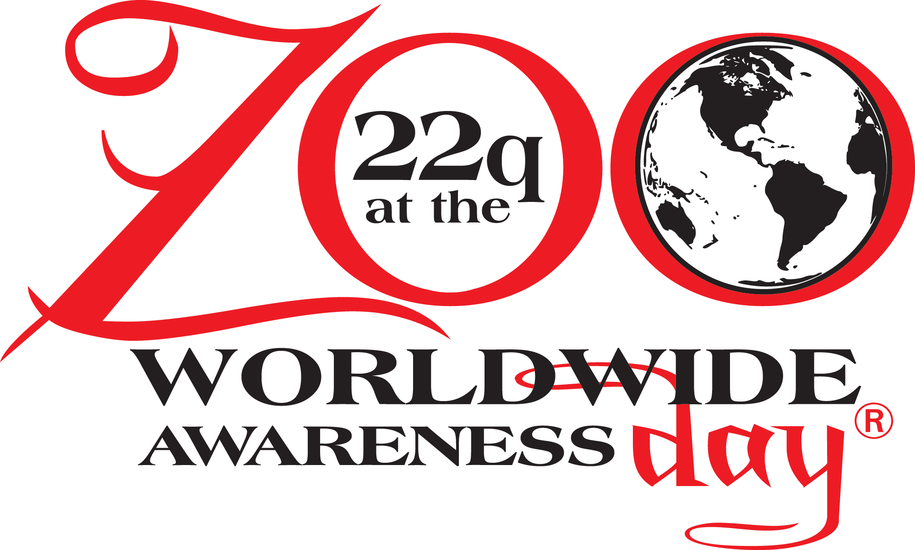

Join the International 22q11.2 Foundation for “22q and ZooM” – a Live Virtual Event Continuing to Unite 22q Families Around the World while Celebrating the 11th Anniversary of “22q at the Zoo” Worldwide Awareness Day!
Sunday * May 16th * 11:00 AM to 2:00 PM EDT
Families can Participate Virtually from Anywhere Around the Globe

Matawan, NJ (May 6, 2020) The International 22q11.2 Foundation, Inc., a family support organization dedicated to improving quality of life for people affected by chromosome 22q11.2 (22q) differences through family and professional partnerships, is proud to host the 11th annual “22q at the Zoo - Worldwide Awareness Day, via Zoom (due to current COVID restrictions), on Sunday, May 16th from 11:00 am – 2:00 pm (US Eastern Daylight Time).

Our 22q at the ZooM Event is aimed at raising awareness for chromosome 22q differences, while bringing families, healthcare providers, and basic scientists working on 22q together to meet, share stories, and learn more about the conditions, while enjoying each other’s company virtually through Quizzo, practicing drawing skills, singing, dancing, and storytelling. Our 22q at the ZooM event welcomes children, adults, and families alike for a mixture of professional presentations, entertainment and games, with surprise guest appearances! In addition to the virtual event, some locations will be hosting IN PERSON meet ups; please check our website for updates daily at:
https://www.22q.org/awareness-events/awareness/annual-22q-at-the-zoo/ .

No matter where you live, from busy cities to rural communities, families will share in celebrating 22q at the Zoo – Worldwide Awareness Day!

Please visit https://www.22q.org/22q-and-zoom/ for a preview of the offerings for the day, such as:

- Join the live Zoom feed from the comfort of your home via the following link: (Link available week of event)
- Click on the link or copy and paste the link into your browser to join
- JOIN Zoom anytime during the 3-hour period and meet and connect with others from across the globe
- Post well wishes and photos on Facebooks official “22q at the Zoo Worldwide Awareness Page”
- Wear a vintage 22q at the Zoo – Worldwide Awareness T-shirt, since part of the fun is seeing how many folks can represent the years of official T-shirts
- Don’t have an official T-shirt? No problem, just wear red
- Post the photos online here: https://dropevent.com/gallery/22qthezoo2020/
- We will create a virtual slide show to share following the event as a World-Wide 22q11.2 Pick-Me-Up!

“The International 22q11.2 Foundation’s 22q at the Zoo – Worldwide Awareness Day is the largest activity for chromosome 22q11.2 conditions on the planet. In fact, more than 100,000 people in over 120 cities on 6 continents have been touched by this event over the past 10 years,” said Donna McDonald-McGinn MS, LCGC, Director, 22q and You Center at The Children's Hospital of Philadelphia, Clinical Professor of Pediatrics at The Perelman School of Medicine at the University of Pennsylvania and Founding Board Member of the International 22q11.2 Foundation, Inc. “The number of children and adults undiagnosed is staggering. These conditions may cause a variety of medical problems such as heart defects, problems fighting infection, differences in the palate (roof of the mouth), and developmental delay or autism, to name a few, but no two people are affected in the same way. With increased awareness, we will drive enhanced detection and personalized care for individuals with 22q and their families,” said McDonald-McGinn.

The International 22q11.2 Foundation, founded in 2003, was created to support families affected by 22q11.2 deletions (due to a small piece of chromosome 22 missing) and later changed its name to include families with 22q11.2 duplications (an extra piece of chromosome 22 material included). The Foundation offers the following to 22q families: opportunities to connect with other 22q families, educational seminars and conferences for families to learn more about the conditions from medical
experts across the world who serve on the Medical Advisory Board, informational updates providing the latest on 22q from researchers in the field, and strengthening support of one another via friend-raising events.

For information on “22q and ZooM,” the 11th Annual Worldwide Awareness Day event, please visit https://www.22q.org/22q-and-zoom/ or join the 22q at the Zoo Worldwide Awareness Day group: https://www.facebook.com/groups/22qAtTheZooWorldwideAwarenessDay/. Donations to support the Foundation are accepted at www.22q.org. For more information on 22q11.2 deletion or duplication, visit http://www.22q.org.

Contact:
Terri Grunduski International 22q Foundation 404-226-7497

###

